Summary Post
In reviewing other reflections on TrueCrypt and Junestam & Guigo’s (2014) cryptanalysis, I think it is important to recognise – as Brayshaw (2024) did – that a fork of TrueCrypt is available in the form of VeraCrypt, which has mitigated against identified vulnerabilities and offers ongoing support (IDRIX, 2024). However, Spero, Stojmenović & Biddle (2019) found their to be very poor usability of VeraCrypt, with an overuse of technical jargon being cited as one of the main problem, as well as a danger of unintuitive interfaces that could lead to sensitive data being overwritten.

I agree with a number of posts that reference TrueCrypt’s discontinuation, however I believe that this was perhaps overly focussed on, with vulnerabilities skimmed over and not enough analysis conducted on the main, specific vulnerabilities from Junestam & Guigo’s (2014) study and the suggested mitigations.

One area that came to light in discussions was that of information leaking, wherein it was discussed that TrueCrypt’s designers should have implemented better memory management and resource handling, as the system is vulnerable to paging out sensitive data (Junestam & Guigo, 2014). A suggested solution from Junestam & Guigo’s (2014) cyptanalysis study was to pool sensitive data into one memory location so that it can be locked down. However, after reflection this solution does not seem without its drawbacks in that, if attackers found a way to access this one memory location, exposure of all sensitive data would be catastrophic.

As security threats become increasingly more elaborate and complex due to increased computational power (Junestam & Guigo, 2014), the challenge will be not only ensuring that new vulnerabilities are addressed, but also ensuring that older mitigations are revisited regularly in order to ensure that they are still best practice in light of for emerging attack strategies.
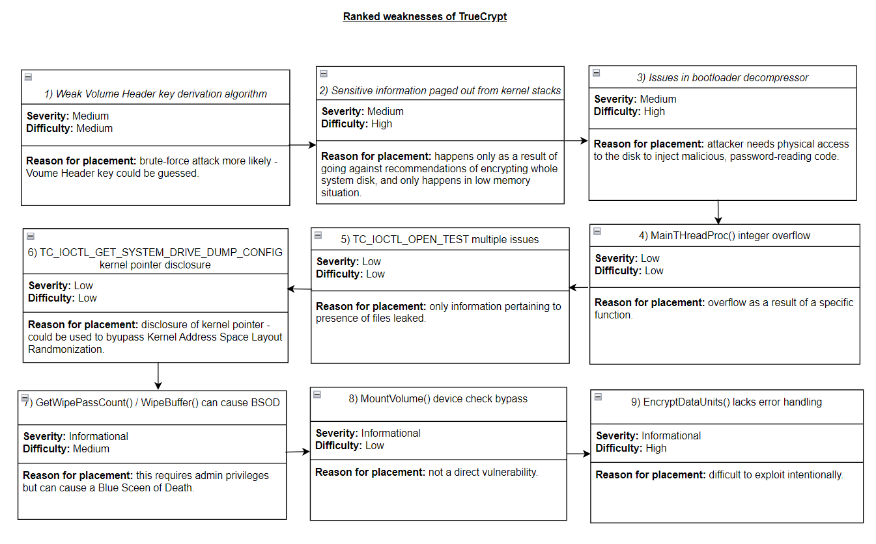
References

Brayshaw, T (2024). Initial Post. SSDCS-PCOM7E: Secure Software Development. Forum post submitted to the University of Essex Online.

IDRIX. (2024) VeraCrypt: Free Open Source Disk Encryption. Available from: https://www.veracrypt.fr/en/Home.html [Accessed 18 October 2024].

Junestam, A. & Guigo, N. (2014) Open Crypto Audit Project: TrueCrypt Security Assessment. Available from: https://opencryptoaudit.org/reports/iSec_Final_Open_Crypto_Audit_Project_TrueCrypt_Security_Assessment.pdf [Accessed 01 October 2024].

Spero, E., Stojmenović, M. and Biddle, R. (2019) ‘Helping users secure their data by supporting mental models of VeraCrypt’, HCI International 2019 - Posters, Cham: Springer International Publishing, pp. 211-218. Available from: https://link-springer-com.uniessexlib.idm.oclc.org/chapter/10.1007/978-3-030-23522-2_27 [Accessed 18 October 2024].

